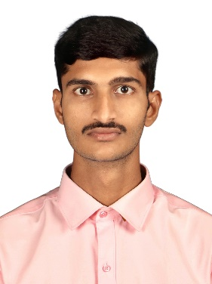**SRINATH KISHORE A**

**Phone**: +91 9626416635

**Email**: [srinathkishore.a@gmail.com](mailto:srinathkishore.a@gmail.com)

**LinkedIn**: <https://www.linkedin.com/in/srinathkishore>

**GitHub/Portfolio**: <https://srinathkishore.github.io/>

**Location**: Coimbatore, Tamil Nadu, India.

**Professional Summary**

A highly motivated and detail-oriented Software Developer with 9 months of hands-on experience in implementing and optimizing ERP systems. Proficient in web technologies such as HTML, CSS, and JavaScript, as well as programming languages like Python and Java, with a strong foundation in Infor ERP systems.

**Technical Skills**

* **Web Designing**: HTML, CSS (Bootstrap).
* **Programming Languages**: Java, Python, JavaScript.
* **ERP Systems**: Infor Landmark ERP.
* **Database Management**: SQL, MySQL.
* **Version Control**: Git, GitHub.
* **Operating Systems**: Windows, Linux (Kali, Ubuntu).

**Professional Experience**

**Software Engineer**

Greeno Tech Solutions Pvt. Ltd. — Coimbatore, Tamil Nadu, India.

June 2024 – Present

* Customize Infor ERP solutions to meet diverse business needs, developing and debugging JavaScript and Infor LPL for ERP functionalities.
* Troubleshoot and resolve system issues, collaborating with teams to gather requirements and implement effective solutions.
* Create and maintain detailed process documentation while staying updated with industry trends and ERP technology advancements.

**Education**

**Bachelor of Engineering in Computer Science and Engineering** (2020 – 2024)

Hindusthan College of Engineering and Technology — Coimbatore, Tamil Nadu, India.

* **CGPA – 8.67 (First Class with Distinction)**
* Served as the **TRF Chairman** in the **Rotaract Club of HICET** during the year 2022–2023 and organized several social events, including a Drug Awareness Rally, Blood Donation Camp, and more.

**Certifications and Courses**

* **Cybersecurity Essentials** — Cisco Networking Academy — Aug 2021
* **Acquiring Data (Level 1 - AI Fundamentals of AI ASCEND)** — Accenture — Sep 2021
* **Introduction to Python** — Infosys Springboard — Jan 2022
* **Introduction to Web Design and Development** — LinkedIn — Dec 2022
* **Hands-On Introduction: JavaScript** — LinkedIn — Jan 2023
* **Java (Basic)** — HackerRank — Apr 2024
* **Python (Basic)** — HackerRank — Apr 2024
* **JavaScript (Intermediate)** — HackerRank — Apr 2024
* **JavaScript Foundations Professional Certificate** — Mozilla — Dec 2024
* **Kali Linux Essential Training** — LinkedIn — Dec 2024

**Professional Development**

* Attended tech events such as the Y20 Youth Festival on Upcoming Trends in Technology, conducted by G20, and others to expand my network and enhance my knowledge in the sector.
* Regularly participated in online courses and certifications on platforms like LinkedIn Learning, HackerRank, and others to stay updated with current technologies and best practices.

**Languages**

* Tamil (Native)
* English (Fluent)
* Hindi (Beginner)

**Self-Attestation**

I hereby declare that the information provided in this CV is true, complete, and accurate to the best of my knowledge and belief.



Srinath Kishore A,

+91 9626416635.